**EDGE DETECTION**

**Edge Detection:**

i=imread('house (2).tiff');

j=rgb2gray(i);

g1=edge(j,'sobel');

g2=edge(j,'prewitt');

g3=edge(j,'roberts');

subplot(2,2,1)

imshow(i);

title('Original Image');

subplot(2,2,2)

imshow(g1);

title('Edge Detection using Sobel');

subplot(2,2,3)

imshow(g2);

title('Edge Detection using Prewitt');

subplot(2,2,4);

imshow(g3);

title('Edge Detection using Roberts');

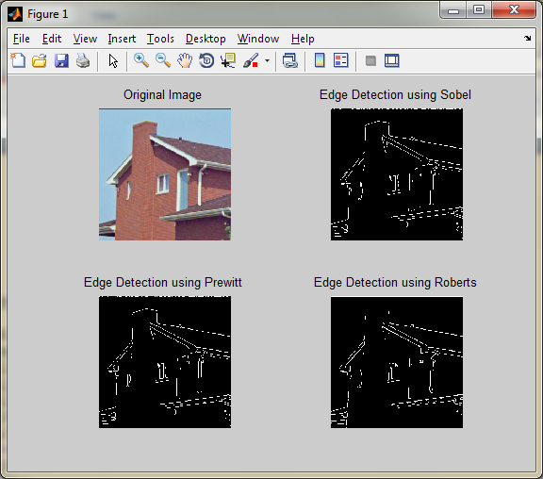

**Thresholding:**

t=graythresh(j);

f=mat2gray(j);

gt=(f>=t);

figure,imshow(gt);

title('Global Thresholding');

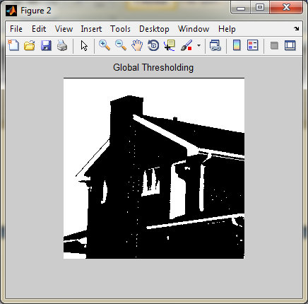

**Hough Transform**

[H,theta,rho]=hough(g1);

h=mat2gray(H);

figure,imshow(imadjust(h),[],...

'XData',theta,...

'YData',rho,...

'InitialMagnification','fit');

title('Hough Transform');

xlael('\theta(degress)')

ylabel('\rho')

axis normal

hold on

colormap(hot)

